

Program Book

**Community Service Project**

**AP STATE COUNCIL OF HIGHER EDUCATION**

**(A STATUTORY BODY OF GOVERNMENT OF ANDHRA PRADESH)**

# COMMUNITY SERVICE PROJECT REPORT

On

**STUDY ON THE PILIMINARY KNOWLEDGE OF AQUACULTURE**

By

### T. KEERTHIVARDHAN (21JN1A05H3)

Under the Guidance of

**MRS. I. SHALINI M.Tech**

**Assistant Professor DEPARTMENT OF CSE**



### DEPARTMENT OF COMPUTER SCIENCE AND ENGINEERING

**SREE VENKATESWARA COLLEGE OF ENGINEERING**

**(UGC AUTONOMOUS INSTITUTION)**

(Approved by AICTE, New Delhi and Affiliated to Jawaharlal Nehru Technological University – Anantapur) GOLDEN NAGAR, NH5 BYPASS ROAD, NORTH RAJUPALEM, KODAVALURU(V&M), SPSR NELLORE

An ISO 9000:2015 Certified Institution

**2023-2024**

# PROGRAM BOOK FOR COMMUNITY SERVICE PROJECT

**Name of the Student :** T.KEERTHI VARDHAN

**Name of the College :** SREE VENKATESWARA COLLEGE OF

ENGINEERING

**Registration Number :** 21JN1A05H3

**Period of CSP :** 8 WEEKS

**FROM:** 01-05-2023 **TO:** 25-06-2023

**Title :** STUDY ON THE PILIMINARY KNOWLEDGE OF AQUACULTURE

**Address of the Community :** komarica(V), Indukurpet(M),

SPSR Nellore(Dt), Andhra Pradesh, Pincode: 524314

## Instructions To Students For Community Service Project

#### Please read the detailed Guidelines on Community Service Project hosted on the website of AP State Council of Higher Education https://apsche.ap.gov.in

**Link:https://apsche.ap.gov.in/Pdf/Guidelines%20for%20the%20OJT% 20Int ernship%20Community%20Service%20Project.pdf**

1. It is mandatory for all the students to complete 2 months (180 hours) of Community Service Project as a part of the 10th month mandatory internship/on the job training.
2. Consider yourself as a committed volunteer in the community, you work with.
3. Every student should identify the village/community/habitation for Community Service Project (CSP) in consultation with the College Principal/the authorized person nominated by the principal.
4. Report to the community/habitation as per the schedule given by the College. You must make your own arrangements of transportation to reach the community/habitation.
5. You will be assigned with a Faculty Guide from your College. He / She will be creating a WhatsApp group with your fellow volunteers. Post your daily activity done and/or any difficulty you encounter during the program.
6. You should maintain punctuality in attending the CSP. Daily attendance is compulsory.
7. You are expected to learn about the community/habitation and their problems.
8. Know the leaders and the officials of the community/habitation.
9. While in project, always wear your College Identity Card.
10. If your college has a prescribed dress as uniform, wear the uniform daily.
11. Identify at least five learning objectives in consultation with your Faculty Guide. These learning objectives can address:
    * Information about the community, including the realities and problems of the society.
    * Need for creating awareness on socially relevant aspects/programs.
    * Learning areas of application of knowledge and technologies related to your discipline.
    * Identifying developmental needs of the community/habitation.
12. Practice professional communication skills with team members, and with the leaders and officials of the community. This includes expressing thoughts and ideas effectively through oral, written, and non-verbal communication, and utilizing listening skills.
13. Be regular in filling up your Program Book. It shall be filled up in your own handwriting. Add additional sheets wherever necessary.
14. At the end of Community Service Project, you shall be evaluated by the person in-charge of the community/habitation to whom you report to.
15. There shall also be evaluation at the end of the community service by the Faculty Guide and the Principal.
16. Do not indulge in any political activities.
17. Ensure that you do not cause any disturbance to the inhabitants or households during your interaction or collection of data.
18. Be cordial but not too intimate with the persons you come across during your service activities.
19. You should understand that during this activity, you are the ambassador of your college, and your behaviour during the community service program is of utmost importance.
20. If you are involved in any discipline related issues, you will be withdrawn from the program immediately and disciplinary action shall be initiated.
21. Do not forget to keep up your family pride and prestige of your college.
22. Remember that you are rendering valuable service to the society and your role in the community development will become part of the history of the community.

# COMMUNITY SERVICE PROJECT REPORT

*Submitted in accordance with the requirements for the degree of B.Tech*

Name of the College : Sree Venkateswara College of Engineering Department : Computer Science and Engineering

Name of the Faculty Guide : Mrs. I. Shalini M.Tech, Assistant Professor

Department of CSE

Title : STUDY ON THE PILIMINARY KNOWLEDGE OF AQUACULTURE

Duration of the CSP : 8 WEEKS

From**:** 01-05-2023 To: 25-06-2023

Name of the Student : T. KEERTHIVARDHAN Program of Study : UG, B.TECH

Year of Study : 3rd year

Register Number : 21JN1A05H3

Date of Submission :

## Student’s Declaration

I **T. KEERTHIVARDHAN,** a student of II-year B. Tech Program, Reg. No: **21JN1A05H3** of the Department of CSE, In **SREE VENKATESWARA COLLEGE OF ENGINEERING** College do hereby declare that I have completed the mandatory community service from **01-05-2023** to **25-06-2023** in **STUDY ON THE PILIMINARY KNOWLRDGE OF AQUACULTURE**. Program under the

Faculty Guideship of **MRS. I. SHALINI M.Tech, Assistant Professor, Department of CSE** in **SREE VENKATESWARA COLLEGE OF ENGINEERING.**

(Signature and Date)

**Endorsements**

Faculty Guide

Head of the Department

Principal

## Certificate from the Official Community

This is to certify that **T. KEERTHIVARDHAN,** Reg. No **21JN1A05H3** of SREE VENKATESWARA COLLEGE OF ENGINEERING underwent community service in **STUDY ON THE PILIMINARY KNOWLEDGE OF AQUACULTURE** from **01- 05-2023** to **25-06-2023.**

The overall performance of the Community Service Volunteer during his/her community service is found to be (Satisfactory/Good).

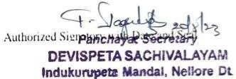

### ACKNOWLEDGEMENTS

I would like to take this opportunity to acknowledge everyone who has helped us in every stage of this project. I express my deep sense of gratitude to all those who have been instrumental in the preparation of this project.

My most sincere and grateful acknowledgments to **Dr. P. GUNA SEKHAR, CHAIRMAN**

who took keen interest and encouraged us in every effort throughout this course.

I own my gratitude to **Dr. V. ANIL KUMAR, Principal**, SREE VENKATESWARA COLLEGE OF ENGINEERING, NELLORE, and **Dr. K. VENKATA NAGENDRA**,

**Professor and Head of the Department**, Computer Science and Engineering for giving us the opportunity to do this community service project on the topic **STUDY ON THE PILIMINARY KNOWLRDGE OF AQUACULTURE.**

I take this opportunity to express my sincere deep sense of gratitude to our guide,

**Mrs. I. SHALINI, Assistant Professor, Department of CSE**, for her significant suggestions and help in every respect to accomplish the report.

I would like to thank Community Service Project coordinator **Mr. G. VIDYA SAGAR, Assistant Professor, Department of CSE** for his persisting encouragement and keen interest in discussions have benefited us to an extent that cannot be spanned by words.

Also, I would like to thank the HEAD OF DEVISPET SACHIVALAM VRO (NARANAREDDY PET, NELLORE) for their constant support and encouragement.

Finally, I am thankful to the technical and non-technical staff of SREE VENKATESWARA COLLEGE OF ENGINEERING, NELLORE, and also parents, friends and all my well-wishers for their assistance in finishing the Community Service Project Successfully.

**T.KEERTHIVARDHAN 21JN1A05H3**

### CHAPTER 1: EXECUTIVE SUMMARY

##### INTRODUCTON OF COMMUNITY SERVICE

1. **DEFINING:**

Community service is work done by a person or group of people that benefits others. It is often done near the area where you live, so your own community reaps the benefits of your work. You do not get paid to perform community service, though sometimes food and small gifts. like a t-shirt, are given to volunteers.

Community service can help any group of people in need: children. senior citizens. People with disabilities. English language learners. and more. It can also help animals, such as those at a shelter. and it can be used to improve places. such as Local Park. historicbuildings, or scenic area as well. Community service is often organized through a local group. such as a place of worship, school. or non-profit organization. You can also start your own community service projects.

##### BACKGROUND:

Community service is a non-paying job performed by one person or a group of people for the benefit of their community or its institutions. Community service is distinct from volunteering since it is not always performed on a voluntary basis. It may be performed for a variety of reasons.

* It may be required by a government as a part of citizenship requirements. like the mandatory “I- land and hitch-up services” for some municipalities in Germany. or generally in lieu of military service or for civil conscription services.
* It may be required as a substitution of. or in addition to, other criminal justice sanctions — when performed for this reason it may also be referred to as communitypayback.
* It may be mandated by schools to meet the requirements of a class, such as in the case of service- learning or to meet the requirements of graduating as class valedictorian.
* In the INDIA. it has been made a condition of the receipt of certain benefits. [dubious

— discuss] (see Workfare in the INDIA

##### NEED/IMPORTANCE:

Community Service Has several Important Benefits Engaging in community service provides students with the opportunity to become active members of their community and has a lastin2. positive impact on society at large. Community service or volunteerism enables students. to acquire life skills and knowledge. as well as provide a service to those who need it most. These are some of the common benefits of participating in a community service program:

* 1. **: Psychological benefits:** Volunteering increases overall life satisfaction and helpsyou feel good about yourself because you are helping others. It can also help to decrease stress and ease depression.
  2. **: Social benefits:** Volunteering engages students with the community, creates special bonds with the population being served, and increases social awareness andresponsibility.
  3. **: Cognitive benefits:** Volunteering helps students enhance their personal knowledge, grow from new experiences, and develop better interpersonal communication skills. Participating in community service not only makes a difference to the organization and people being served. but also makes a differenceto every student’s career prospects. Participating in community service activities helps to enhance student resumes by allowing students to obtain work-related skills prior to graduation. builds good references for employers in regard to community involvement, and provides a forum to network with future potential employers. It also helps students develop civic and social responsibility skills and become more aware of what their community needs. You can also make a positive contribution to your community by earning an online degree in nursing. criminal justice or psychology. Contact us today for more information about our programs where youcan learn how to help real people and leave a positive impact on the world.

##### FORMS OF COMMUNITY SERVICE:

There are three types of community service and service-learning: direct. in-direct and advocacy. Once a community need is identified, the project activities that are developed will align with one or more of the types. Below are definitions and additionalexamples of each type of community service and service- learning.

##### DIRECT:

You can develop direct service activities where students interact with the recipients of service or the physical environment they have targeted for improvement. You and your chapter can volunteer at a food kitchen to serve community members in need. Or perhaps you can work with your community senior centre to create an adopt a- grandparent program that lasts beyond FFA Week.

##### IN-DIRECT:

If you don’t have the ability to come in direct contact with the beneficiaries of service. You can organize an indirect service activity where students channel resources to a problem but do not interact with those being served. This can include organizing a canned food drive to donate to a food pantry in a neighbouring community or participating in a community beautification project.

##### ADVOCATE:

It is important to always be an advocate for the issues that inspire you. During advocacy service activities, students bring awareness to an issue and inspire others to take action. Advocacy can also address the underlying causes of a social problem by attempting to influence policymakers or elected officials.

##### WAYS TO PARTICIPATE IN COMMUNITY SERVICE:

There are hundreds of ways to participate in community service, depending on the skills and interests. Some common community service examples include:

* Working with school children: Tutoring children after school. Collecting schoolsupplies to donate, planting a school garden. Working with senior citizens.

Visiting residents of a retirement centre. Delivering meals to senior citizens.Driving them to appointments.

* Improving the environment: Holding a recycling contest, planting trees.creating a new trail at a nature centre.
* Helping low-income people: Passing out food at a soup kitchen, collecting usedclothes to be donated. making first aid kits for homeless shelters.

### CHAPTER 2: OVERVIEW OF THE COMMUNITY

#### The key components of Study on the preliminary knowledge of aquaculture Awareness:

Aquaculture health and hygiene programs would educate individuals involved in the industry about the importance of maintaining healthy aquatic environments and the impact on aquatic species. This includes providing information on water quality management, disease prevention, and sustainable aquaculture practices.

#### Water Quality Management:

These programs would emphasize the significance of maintaining optimal water quality in aquaculture facilities. This involves monitoring and controlling factors like oxygen levels, temperature, pH, and nutrient balance to ensure a healthy environment for aquatic organisms.

#### Disease Prevention and Control:

Disease prevention and control measures in aquaculture would focus on strategies to prevent the outbreak and spread of diseases among aquatic species. This includes biosecurity measures, vaccination if applicable, and quarantine protocols.

#### Nutritional Management:

In aquaculture, proper feeding and nutrition are vital. Programs would provide guidance on the appropriate diets for different species, feed quality, and feeding practices to ensure the growth and health of the aquatic organisms.

#### Environmental Sustainability:

Sustainability in aquaculture programs would address responsible practices to minimize environmental impact. This includes managing waste, minimizing the use of chemicals, and promoting responsible resource use.

#### Regulatory Compliance:

Health and hygiene programs in aquaculture may also include education about relevant regulations and standards governing the industry, ensuring that practices align with legal requirements.

#### Conclusion:

In summary, aquaculture health and hygiene programs encompass education and awareness, water quality management, disease prevention, nutritional management, sustainability, and regulatory compliance. These programs aim to ensure the well-being of aquatic species, environmental sustainability, and the overall success of the aquaculture industry.

**CHAPTER 3: COMMUNITY SERVICE PART**

#### Aquaculture Health and Hygiene:

Health in aquaculture refers to the well-being of aquatic organisms and the proper functioning of the aquatic ecosystem. Hygiene practices are essential to maintain the health of aquatic species and the environment. It is important to prevent the spread of diseases and ensure the overall health of aquatic organisms.

#### Maintaining a Clean Aquatic Environment:

To keep the aquatic environment clean in aquaculture, it's necessary to:

Ensure clean and well-maintained aquaculture facilities.

Implement proper water quality management to prevent pollution and disease outbreaks. Manage waste generated by aquaculture activities, including uneaten feed and organic matter. Use effective filtration and water circulation systems to maintain optimal conditions for aquatic life.

Promote responsible aquaculture practices to prevent harm to the surrounding ecosystem.

#### Balanced Nutrition in Aquaculture:

In aquaculture, balanced nutrition is crucial for the health and growth of aquatic species. It involves providing the right mix of nutrients in the diet, including proteins, fats, vitamins, and minerals, to meet the specific nutritional requirements of different aquatic organisms.

#### Prevention in Aquaculture:

To ensure the health and sustainability of aquaculture, prevention measures can include:

* Increasing awareness of disease risks and the importance of biosecurity measures.
* Implementing regular monitoring and health assessments of aquatic populations.
* Adhering to responsible aquaculture practices to minimize stress and disease transmission.
* Avoiding overfeeding and ensuring the proper nutrition of aquatic species.
* Managing stress factors, such as water quality, to promote overall well-being in aquaculture environments.

In conclusion, promoting health and hygiene in aquaculture involves maintaining a clean aquatic environment, providing balanced nutrition, and preventing disease outbreaks. These practices contribute to the well-being of aquatic species and the overall success of the aquaculture industry.

# ACTIVITY LOG FOR THE FIRST WEEK

|  |  |  |  |
| --- | --- | --- | --- |
| **DAY**  **& DATE** | **BRIEF DESCRIPTION OF THE DAILY ACTIVITY** | **LEARNING OUTCOMES** | **PERSON**  **IN-CHARGE SIGNATURES** |
| **DAY-1** | WENT TO SACHIVALAYAM | I met with the VRO officer on behalf of asking permission for doing "COMMUNITY SERVICE PROJECT |  |
| **DAY-2** | Introduction to aqua farming | I gathred information about my project title. |  |
| **DAY-3** | Why aqua farming is important | I learned about important’s of aquaculture. |  |
| **DAY-4** | Visited the fish or sea food market. | I came to know the prices of the fishes. |  |
| **DAY-5** | Survey with the fisherman. | I had learnt communicating with the fisherman. |  |

|  |  |  |  |
| --- | --- | --- | --- |
| **DAY-6** | Survey with the fish vendor. | Collected the prices of the fishes in different seasons. |  |

**WEEKLY REPORT**

## Week-1(From Dt 01/05/2023 to 06/05/2023)

#### Objective of the Activity Done:

**Detailed Report:**

**DAY-1:** I have started “COMMUNITY SERVICE PROJECT” on “AQUAFARMING”. For doing

project work without any restrictions, I havemet VRO officer and explained him about the community service project that is assigned to us by the JNTUA to get general awareness on society on behalf of that I have chosen aqua farming. To do this service project, I haveverified Many sea food areas in our locality

**DAY-2:** Aqua farming involves cultivating freshwater, brackish water and saltwater populations under controlled or semi-natural conditions, and can be contrasted with commercial fishing, which is the harvesting of wild fish. Aqua farming can be conducted in completely artificial facilities built onland , as in the case of fish tank, ponds, aqua ponics or raceways, where the living conditions on human control such as water quality , feed, temperature.

**DAY-3:** Aqua farming is also one of the world's most efficient and sustainable methods to produce high-quality protein. The industry has low carbon footprint and feed conversion ratio as well as high protein and energy retention. Skretting provides innovative and sustainable nutritional solutionsthat best support the performance of farmed fish and shrimp..

**DAY-4:** When I arrived at the fish market, it was overcrowded, and the smell of fish filled the air. This market is on the outskirts of the city where I live. There were various types of fish, and the vendors selling fish of divergent types. Since it was the weekend, people from all walks of life were there.

**DAY-5:** I met with fisherman he is catching fishes to earn money and build his future. He knows where the types of fishes live in the river. might encourage fishermen to adopt fishing gear biodegradable in the marine environment

**DAY-6:**The data were collected with the help of local fishermen's, fish farmers and fish vendors. The fish is the market comes from ponds, lakes and rivers. The India fish market size reached a value of around INR1,232 billion in the year2020.

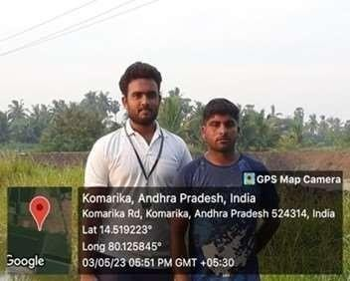

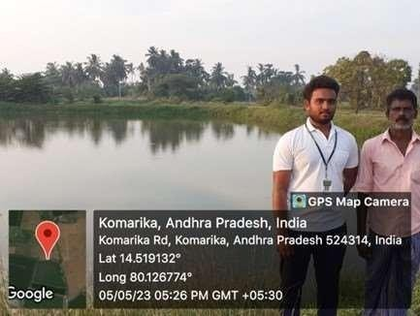

# ACTIVITY LOG FOR THE SECOND WEEK

|  |  |  |  |
| --- | --- | --- | --- |
| **DAY**  **& DATE** | **BRIEF DESCRIPTION OF THE DAILY ACTIVITY** | **LEARNING OUTCOME** | **PERSON IN-**  **CHARGE SIGNATURE** |
| **DAY-1** | Understanding the ponds structure, like their size and depth. | The maximum number of ponds I visited are in rectangular shapes with  depth range of 5 to 6 feet. |  |
| **DAY-2** | The maximum number of ponds I visited are in rectangular shapes with depth range of 5 to 6 feet. | Power is the main source in aquaculture, to run all the electrical equipment  like motors, areators ...etc. |  |
| **DAY-3** | Understanding the ponds structure, like what type of soil and water is used. | The best soil for the fish in the pond tor fresh water especial the sandy clay soil is the best for the  fishes |  |
| **DAY-4** | Conducted survey how the people deal with the aquatic weeds. | After installation of water in the pond some unwanted plants will be grown, have to remove them from pond. |  |
| **DAY-5** | Conducted survey on how they deal with unwanted fishes. | if unwanted fishes are grown then they should be removed to avoid their effects on other main fishes. |  |
| **DAY-6** | Conducted survey on how the deal with the unwanted fishes. | In the pond, if unwanted fishes are grown then they will be removed, to avoid the effects on the other  fishes. |  |

**WEEKLY REPORT**

## Week-2(From Dt 08/05/2023 to 13/05/2023)

#### Objective of the Activity Done:

**Detailed Report:**

**DAY-1:**The optimum size of the pond is rectangular in shape with size varying from 2 to 4 hectares with a depth range from 5 to 6 feet.

**DAY-2:**Power is the main source to run the all Electrical equipment like motors, aerators etc..,this all work with the power supply. No any power supply the culture will stop to get loss in that culture. Transformers are distributed the current to all Electrical equipment. Problem Power cut is the major problem in aqua shrimp farm culture. The motors and aerators are working on 24 hrs. That aerators are stopped due to power cut the prawns are not get the oxygen. To face some problem the prawns are jumped into the land due to lack of oxygen. So farmers faces a so many problems due to power cuts , major problem in aqua shrimp culture.

**DAY-3:** The soil type in the pond and its fertility status very much. However the best soil for the fish pond for the fresh water fishes especially the fishes is sandy clay soil with neutral pH ranging between 6.5 to 8.5 Though the soil type cannot be changed except in the long range plans, the pH has to be brought to neutral if the pond soil and water are saline, alkaline or acidic.

**DAY-4:** Most of the aquatic weeds in the fish pond are undesirable. They not only take away the nutrients but also upset the oxygen balance in the water by releasing carbon dioxide into the pond during the night. Aquatic weeds also obstruct the movement of fishes as well as the netting operations. The aquatic weeds may be free floating surface weeds, submerged weeds, rooted emergent weeds, marginal shallow water weeds and algae. All these weeds have to be eliminated

**DAY-5:** Hatchery of the production of seed of shrimp culture. Hatchery’s to produce healthy seed.

**DAY-6:** The unwanted fishes in the ponds may be predatory or weed fishes. They compete with cultured fish for feed, nutrients and space. These predatory and weed fishes can be eliminated through repeated netting of the pond. Another method of eradicating the above mentioned unwanted fishes is to drain out the whole water from the pond and eliminating all of them manually and refill the pond with water.

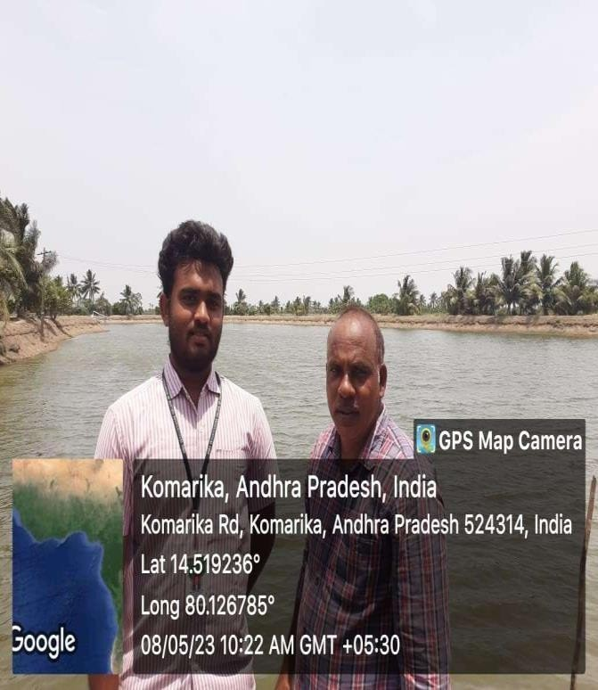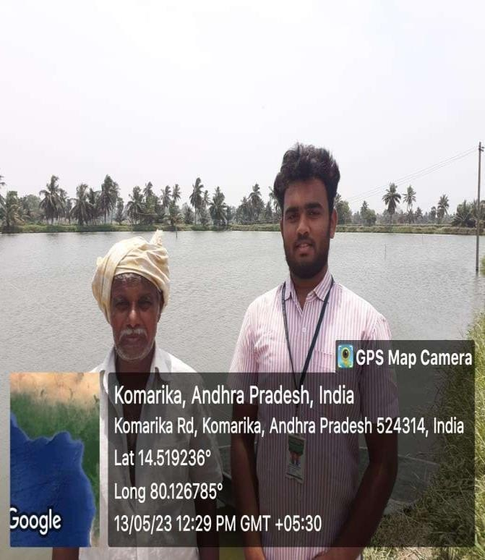

# ACTIVITY LOG FOR THE THIRD WEEK

|  |  |  |  |
| --- | --- | --- | --- |
| **DAY**  **& DATE** | **BRIEF DESCRIPTION OF THE DAILY ACTIVITY** | **LEARNING OUTCOME** | **PERSON IN-CHARGE SIGNATURE** |
| **DAY-1** | Red Pest and Anchor Warm Symptoms | Bloody streaks on body, fins and/or tail appear, so it is called red pest. |  |
| **DAY-2** | On this day, I got a chance to ask what type of fishes are harvested. | Farmers harvest mainly three types of fishes gandi, katla, roopchand |  |
| **DAY-3** | Aqua feeds refer to any feed given to aquatic farmed animals as part of aquaculture. | Fish (both farmed and wild) require a balanced mix of essential nutrients such as amino acids, fatty acids, and vitamins to thrive. |  |
| **DAY-4** | Discussion with the farmers on aqua chemicals. | AQUA CHEMICALS takes  the time to understand your exact needs before recommending a chemical treatment program for industrial cooling systems. |  |

|  |  |  |  |
| --- | --- | --- | --- |
| **DAY-5** | On this day, I have studied the overall pond maintenance | I learnt that the pond maintenance is essential for good production of fishes. |  |
| **DAY-6** | On this day, I get to know about the transportation services | I interact with the transportation service, their was more than one transportation vehicle, are loaded with the bulk of fishes to export. |  |

**WEEKLY REPORT**

## Week-3(From Dt 15/05/2023 to 20/05/2023)

#### Objective of the Activity Done:

**Detailed Report:**

**DAY-1:** Red Pest Symptoms:

Bloody streaks on body, fins and/or tail appear, so it is called red pest. In severe infection these streaks could lead to ulceration and possibly followed by fin and tail rot with the tail and fins falling off. Treatment: External treatments are usually not effective as the diseases at the appearance of disease

1. Treat the tank with a disinfectant and clean the tank as best as possible.
2. Use acriflavine or monacrin using a 0.2% solution at the rate of 1ml per liter.

**DAY-2:** Farmers harvest mainly three types of fishes. Gandi, katla, roopchand. These fishes can grow in any environment.

**DAY-3:** The feeds, in the form of granules or pellets, provide the nutrition in a stable and concentrated form, enabling the fish to feed efficiently and grow to their full potential. Fish meal, Dry fish, Soybean meal, Meat and bone meal, Rape seed cake, Mustered oil cake, Soy protein concentrate, Blood meal, Krill meal, Maize gluten.

**DAY-3:** AQUA CHEMICALS takes the time to understand your exact needs before recommending a chemical treatment program for industrial cooling systems. A full system audit, which includes operational history and inefficiencies, allows your field engineer to determine the potential for corrosion, fouling, and scaling within your cooling system.

**DAY-5:** I have suggested that, maintain oxygen levels in high range Fish use up to 10 times as much oxygen during feeding as they do at rest. Therefore, the more oxygen you have, the more fish can feed and grow faster. if you have low oxygen and feed the fish, you could stress them to the point of death. Feed: When you gave feed to the fishes have to use more protein in the feed, feed them two times in a day. Sanitization: For every 15 days have to do sanitization.

**DAY-6:** I interact with the transportation service, there was more than one transportation vehicle, are loaded with the bulk of fishes to export. Fish Transportation is a process by which fish is transported from one place to another place in a scientific way.

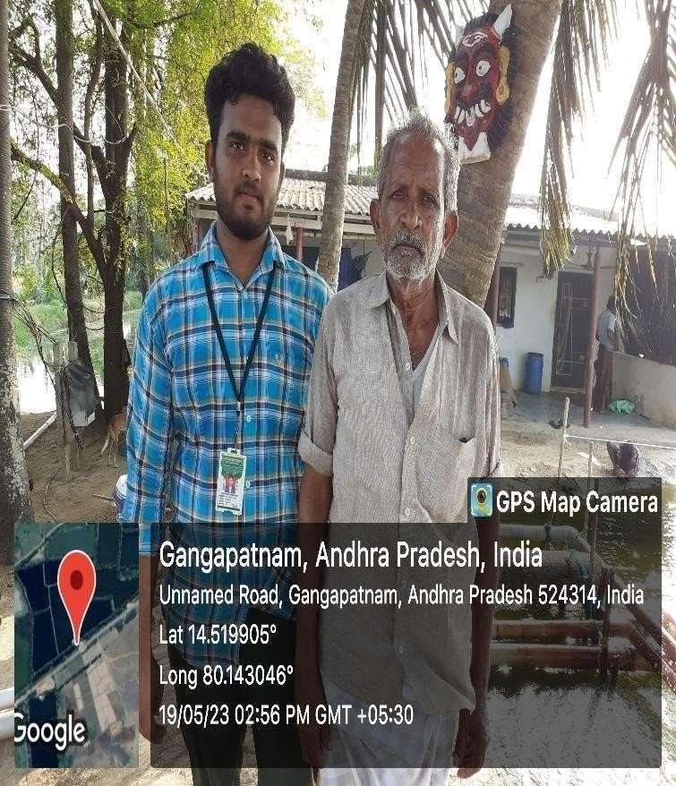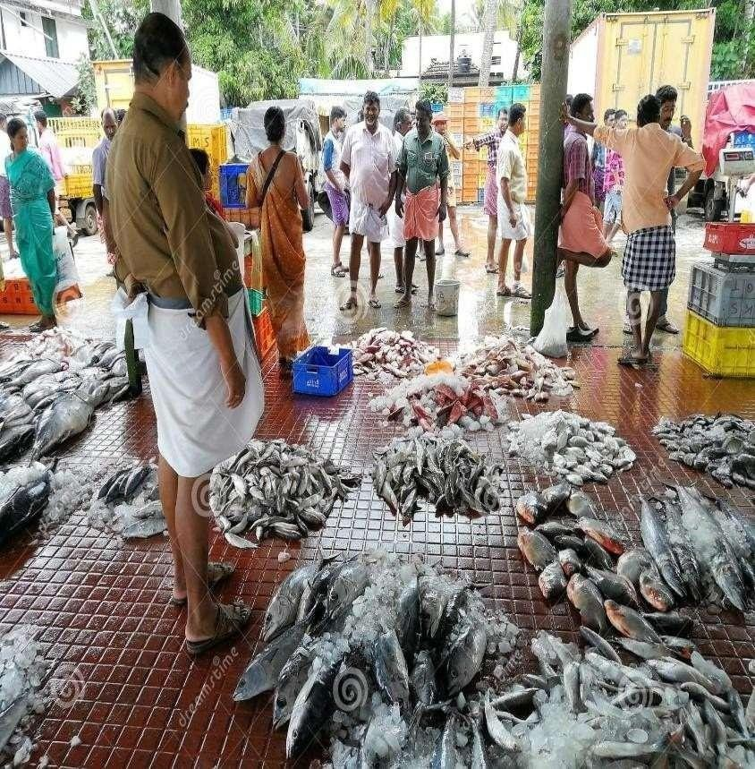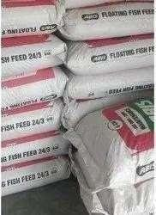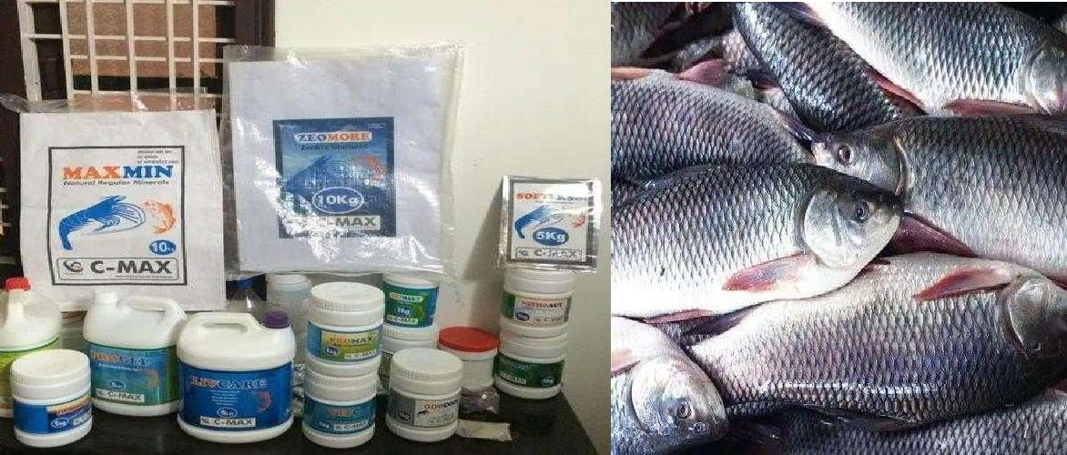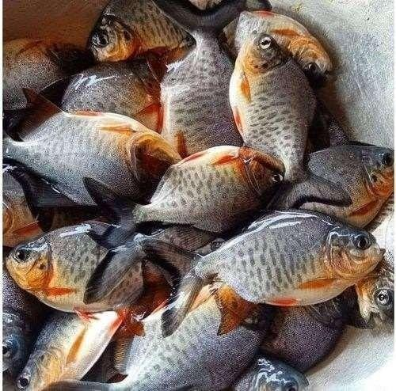

# ACTIVITY LOG FOR THE FOURTH WEEK

|  |  |  |  |
| --- | --- | --- | --- |
| **DAY**  **& DATE** | **BRIEF DESCRIPTION OF THE DAILY ACTIVITY** | **LEARNING OUTCOME** | **PERSON**  **IN-CHARGE SIGNATURE** |
| **DAY-1** | I studied the **“CURRICULUM GUIDELINES”,** my Community Service Project and understood what should be done in this week activity. | I went Throughout the 4th week log in the guidelines. And gained a clarity on this Week work Methodology. |  |
| **DAY-2** | I have visited the Ponds and I Observed the major diseases for fishes. | I have observed the color of the water. As per observation, I found many problems such as changing the color of the water& lack of oxygen. |  |
| **DAY-3** | I observed the major diseases in fish which are faced by the most farmers | The major Diseases were “Head and Lateral disease” “Eye disease”  “Swim Bladder disease”. |  |
| **DAY-4** | On this day, I conducted a small Survey and they told me another major problem in aquaculture. | The farmer’s told me that “they want to grow their fish faster” and also keeping them healthy to make profits from them. |  |

|  |  |  |  |
| --- | --- | --- | --- |
|  |  |  |  |
| **DAY-5** | After the 4days survey, the major problem the Farmers facing were the maintenance of the fish. | By collecting all the data from the farmers, I did some browsing and asked some officials related to this field for the solution. |  |
| **DAY-6** | On this day, I visited the pond and farmers to explain them about the solution I came up with. | I conducted a small campaign like session with the farmers and tells about the solution and listening to their talks on my solutions |  |

**WEEKLY REPORT**

## Week-4(From Dt 22/05/2023 to 27/05/2023)

#### Objective of the Activity Done:

**Detailed Report:**

**DAY-1:** For better implementation understanding the curriculum of CSP is necessary. So, I have studied the guidelines of community service project and understood what To be done in the fourth week. As per my understanding, in this week we need to identify problems in our Project. And we need to mention the solutions for those specified problems. We need to mention the steps in the way of solving those problems.

DAY-2:

I have visited the ponds and I observed the major diseases for fishes. I have observed the color of the water. As per observation, I found many problems such as,

1. Changing the color of the water.
2. Lack ofoxygen.

DAY-3:Main diseases the caused to fishes

1. Head and lateral disease
2. Eye problems
3. Swim bladder disease
4. Head and lateral disease: Begins as small pits on the head and face, usually just above the eye. If untreated, these turn into large cavities and then the disease progresses along the lateral line. Head and Lateral Line Disease is attributed to a nutritional deficiency of one or more of vitamin C, vitamin D, calcium, and phosphorous.
5. Eye problems: Cloudy cornea, opaque lens, poor eye, swelling, blindness.Cloudy cornea can result from a bacterial invasion. Antibiotics may help. Opaqueness can result from poor nutrition or a metacercaria invasion (grubs). Try foods with added vitamins and change the diet to include variety.
6. Swim bladder disease: Abnormal swimming pattern, difficulty in maintaining equilibrium.

Swim bladder problems usually indicate another problem. Swim bladder problems usually indicate another problem.

DAY-4:How To Grow Fish Faster

How To Grow Fish Faster is one of the most common questions all fish farmers have. Today I am going to show you the best way to grow all types of fishes like tilapia, pangasius, rohu, catla, mirgal and all types of fishes. If you have fish ponds and want to make extra profit you have to make one thing very clear, your fishes must NOT DIE and they should grow fast, gain weight as much as possible. It is very easy important to keep fishes alive, if a lot of fishes die then there will be a huge loss. So, to make good money you have to keep the maximum number of fishes alive. DAY-5:

After doing survey, the major problem the farmers are facing were the fish maintenance. I did some research and asked some officials about it and I got a lot of information about how deal with the

diseases and their prevention.

DAY-6: On this day, I conducted a small campaign about the solution for the problems they were facing. I listed the treatment process for it.

Head and lateral disease treatment

HLLE has been reversed by one or more of the following treatments:

1. Increase frequent water changes.
2. Add vitamins to frozen foods.
3. Add flake foods, as they are enriched with vitamins.
4. Add green, either frozen or in leaf form, to the diet.
5. Decrease the amount of beef heart as it lacks many critical nutrients.

Treatment for eye problem: Pop eye (exophthalmia) can result from rough handling, gas embolism, tumours, bacterial infection, or vitamin A deficiency. Gas bubble or bacterial infection can be treated successfully with penicillin or amoxicillin. Blindness can be caused by poor nutrition or excessive light. Lowering the light level and a change of diet to include lots of variety may help prevent it.

Treatment for swim bladder disease: Abnormal swimming pattern, difficulty in maintaining equilibrium.

Swim bladder problems usually indicate another problem listed here. If notice swim-bladder problems in a fish, first check and treat it for other diseases as listed below:

1. Congenitally deformed bladder.
2. Cancer or tuberculosis in organs adjacent to swim bladder.
3. Constipation

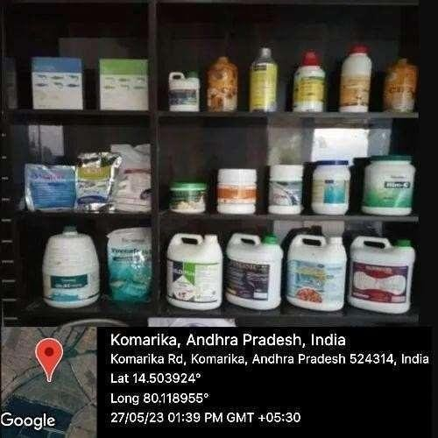

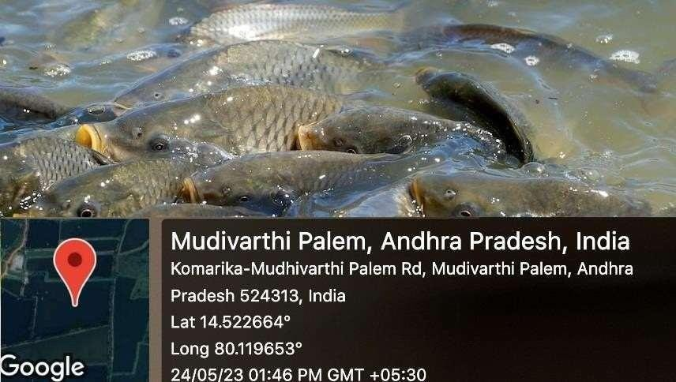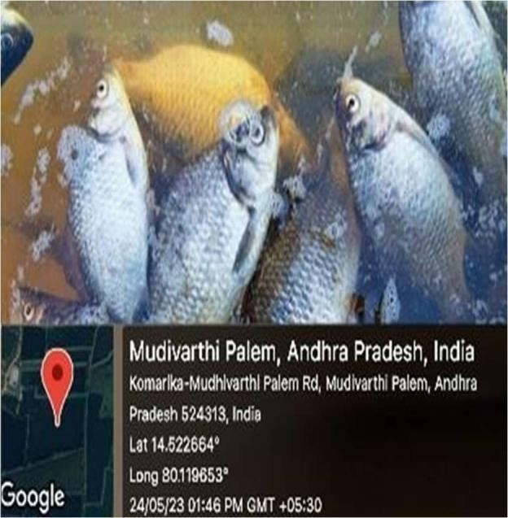

# ACTIVITY LOG FOR THE FIFTH WEEK

**DAY**

**& DATE DAY-1**

**DAY-2**

**BRIEF DESCRIPTION** **OF THE DAILY ACTIVITY**

On the guidelines of “COMMUNITY SERVICE

PROJECT” in the fifth week. I have implemented the treatments for the diseases that what I have found in last two weeks.

### LEARNING OUTCOME

After doing a lot of After implementing the treatment in proper way for the diseases it worked successfully

### PERSON IN-CHARGE SIGNATURE

On this day, the officials who on this day, the officials who deals with the aquaculture told me some important guidelines in implementing the Treatments of the problems.

The officials told me the effective way of treating the fishes, like External treatments are usually not effective.

### DAY-3

Today I and some farmers decided to clean the pond with potassium permanganate with 9 percent.

A 10 to 30minute bath in 10 mg per liters of potassium permanganate, or treat the whole tank with 2 mg per liters, but this method is messy and dyes the water.

.

|  |  |  |  |
| --- | --- | --- | --- |
| **DAY-4** | On this day, I went on the treatment with a common disease which most of the farmers are facing. | Today I decided to go on with the treatment of Head and Lateral diseases. I explained the farmers about its prevention and cure methods also. |  |
| **DAY-5** | On this day, I went on the treatment with the second most common disease which most of the farmers are facing. | Today I decided to go on with the treatment of Eye diseases. I explained the farmers about its prevention and cure methods also. |  |
| **DAY-6** | .On this day, I went on the treatment with the third most common disease which most of the farmers are facing. | Today I decided to go with the treatment of abnormal swimming pattern. I |  |

# WEEKLY REPORT

## Week-5(From Dt 29/05/2023 to 03/06/2023)

#### Objective of the Activity Done:

**Detailed Report:**

**DAY-1:** On the guidelines of “COMMUNITY SERVICE PROJECT” in the fifth week I have implemented the treatments for the diseases that what I have found in last two weeks. After implementing the treatment in proper way for the diseases it worked successfully.

**DAY-2:** Treatment: External treatments are usually not effective as the disease spread At the appearance of disease:

1. Treat the tank with a disinfectant and clean the tank as best as possible.
2. Use acriflavine (trypaflavine) or monacrin (mono-amino-acridine) using a 0.2% solution at the rate of 1 ml per liters.

Do not feed a lot while the fish is being treated.

**DAY-3:** Treatment: Head and lateral disease

A 10 to 30minute bath in 10 mg per liters of potassium permanganate, or treat the whole tank with 2 mg per liters, but this method is messy and dyes the water.

**DAY-4:** Head and lateral disease treatment:

HLLE has been reversed by one or more of the following treatments:

1. Increase frequent water changes.
2. Add vitamins to frozen foods.
3. Add flake foods, as they are enriched with vitamins.
4. Add green, either frozen or in leaf form, to the diet.
5. Decrease the amount of beef heart as it lacks many critical nutrients.

**DAY-5:** I Treatment for eye problem

Pop eye (exophthalmia) can result from rough handling, gas embolism, tumors, bacterial infection, or vitamin A deficiency. Gas bubble or bacterial infection can be treated successfully with penicillin or amoxicillin. Blindness can be caused by poor nutrition or excessive light. Lowering the light level and a change of diet to include lots of variety may help prevent it

**DAY-6:** I Abnormal swimming pattern, difficulty in maintaining equilibrium. Swim bladder problems usually indicate another problem listed here. If notice swim-bladder problems in a fish, first check and treat it for other diseases as listed below:

1. Congenitally deformed bladder.
2. Cancer or tuberculosis in organs adjacent to swim bladder.

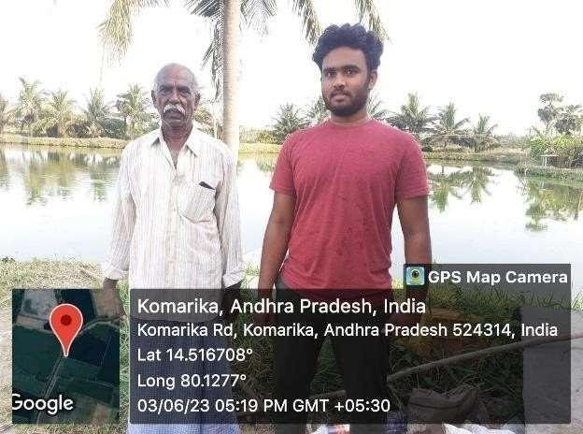 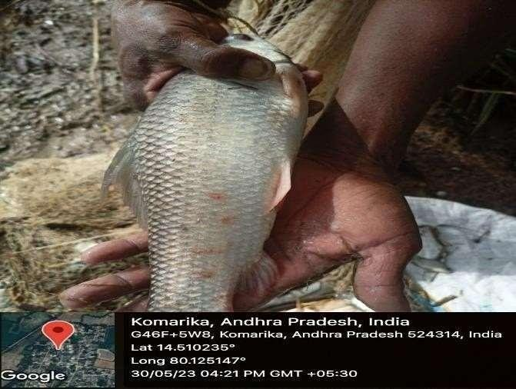

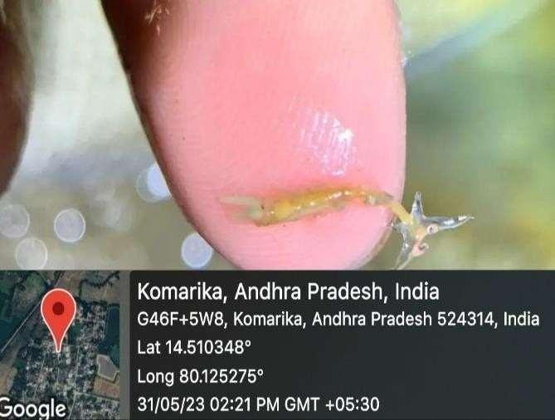

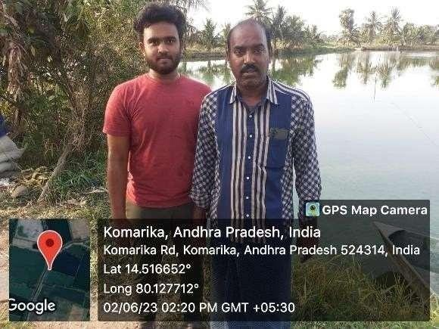

# MINI PROJECT

**Title of the Project:** A webpage designed on the topic **“STUDY ON THE PILIMINARY KNOWLRDGE OF AQUACULTURE”** in the Duration of 3 Weeks **FROM:** 05-06-2023 **TO:** 24-06-2023**.**

#### Abstract:

I started my Community Service Project, by selecting my work area. I decided to choose Devispeta as my work location to do my surveys, campaigns and to understand their problems and solve them using modern as well as traditional methods in that area. I have completed this all work in the 5 weeks comprising 2 weeks for Survey, 1 week for Campaign, 1 week for problem identification and another 1 week for solving that problem. After looking up my vast data of my 5 weeks progress I decided to design a webpage on my progress and to display what Countryside Transformation Initiative mean. I decided to make webpage for my mini project taking a dedicated time period for two weeks. On the 6th week I started to design my webpage. In this week I designed the layout of my webpage and inserted some description related to Countryside Transformation Initiatives. On the 7th week, I went on with colours to make the website beautiful. I adjusted the colours to match my content of the webpage. Then I worked on how to make my website responsive and I achieved it with formal programming language. So, after all this I decided to insert my week progress images to make it more realistic. After this all I tested my webpage how it was going on different screens, I got confirmation that my webpage is responsive on different screens. On the last two days of 7th week, I merged all my team members webpage, which are interconnected by a homepage. In this way I completed my mini project.

#### Existing System:

* + In my first two weeks of survey, I noticed that village people were consuming a lot of plastic which is way ahead of safety level.
  + Second and most important problem I noticed that they were using a lot of pesticides which is not healthy at all for the crops.

#### Proposed System:

* + In the third week of Campaign, I conducted an awareness program on Anti-Plastic, as it can be banned completely at once so I told them to reduce the usage and by progress replace it with jute bags.
  + I conducted my second awareness camp on the concept of organic farming, in which I told them about our traditional farming methods and explained about the organic fertilizers’ future importance and the main, disadvantage of pesticides in long term farming.

#### Requirements:

**Hardware:**

Laptop, Windows 11, i5 Processor, 512 GB SSD, 8GB RAM

#### Software:

VSCODE, HTML5, CSS3, JAVASCRIPT

#### Architecture:

**User and Admin:**

We have designed the webpage without any restriction, that means admin and the user have the same content in matter of view. This is an open-source webpage anyone can view it.

Home

VILLAGE DEVELOPMENTS PLANS

VILLAGE DEMOGRAPHY

AGRICULTURE

AQUACULTURE

TREE PLANTATION

#### Modules:

**Home:**

The homepage starts with display of our webpage name, further it goes on with our “Mission and Vision” and end on with our Traits. We have created buttons to navigate from one page to another.

#### Village Developments Plans:

This page displays, the description of village developments plans along with the purpose of the student selecting this project. At last, there is an activity gallery which displays the student activity progress.

#### Village Demography:

So, this page refers to village demography description, it displays with student interest towards his project, probably the reason for selecting it. At the end an activity gallery is showcased to display his work.

#### Tree Plantation:

The page illustrates the importance of planting trees and the measures of protecting it. It contains the view of seeing the world, Green. Finally, there is an Exhibit of his work at the end of the page to mark the student’s work.

#### Aquaculture:

This page features the aquatic world organisms farming. This page elaborates with a of purpose of this project selection by the student a description of aquaculture and ends by promoting the student’s work.

#### Agriculture:

This page demonstrates the agricultural sector. The page begins with his purpose of selecting this project. He describes his passion towards the agriculture in it. At the end he presents his dedication in activity gallery.

#### Conclusion:

Thus, from looking at my data, surveys, and their problems etc... I conclude that a strong change is needed to thrive the villages towards the path of development. I agree solutions have emerged for the problems, but their useless until they are implemented. In the point of developing villages, I specifically designed this webpage and allowing other inspired minds to join this and take this journey ahead.

#### Website Link:

https://shaikfirdos403.github.io/CEI--Project/

#### Note:

To view the webpage, prefer PC or Laptop. In case of Mobile, use the desktop view for good view.

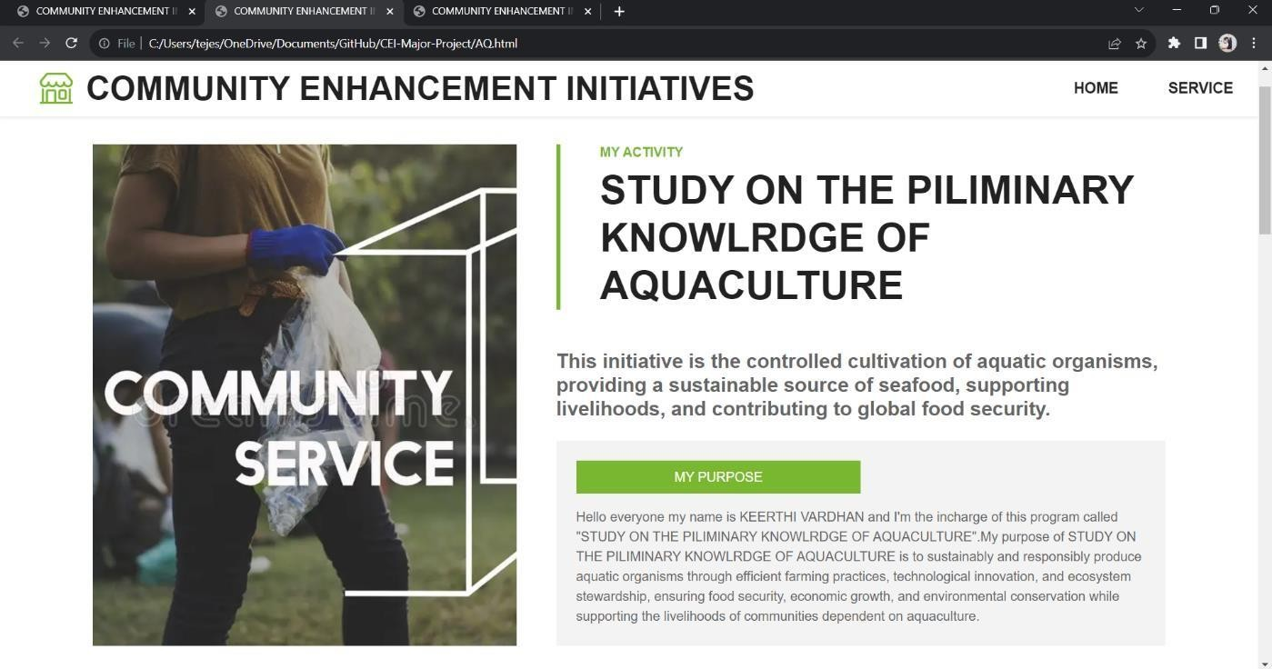

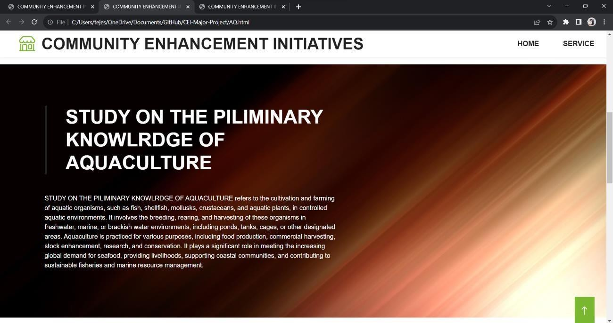

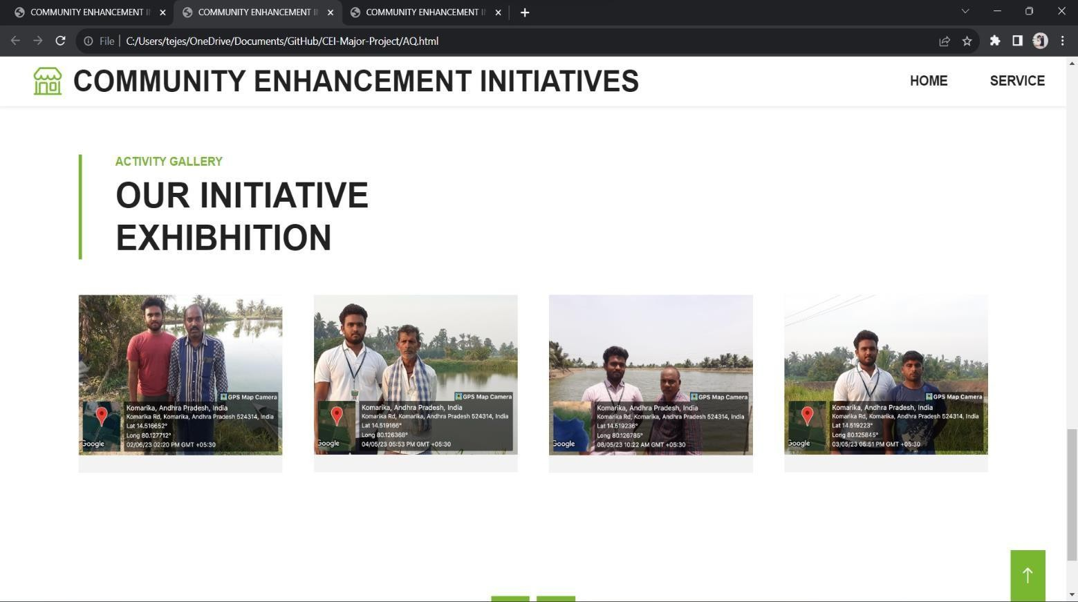

### CHAPTER 5: OUTCOMES DESCRIPTION

* **Enhanced Crop Yield:** Through the implementation of organic farming practices, we witnessed a Notable increase in crop yields, ensuring better food security for the community.
* **Virus Suppression:** The project successfully mitigated the spread of crop – damaging.
* **Improved Soil Health:** Organic farming not only increased crop yield but also enhanced the Overall soil health, making it more resilient for future cultivation.
* **Reduced Chemical Usage:** The promotion of organic farming led to a significant reduction in the use of harmful chemicals, making the environment and crops healthier.
* **Water Conservation:** By advocating the use of canals over borewells, we conserved groundwater Resources and ensured a sustainable source of water for irrigation.
* **Lower Energy Costs:** Utilizing canals reduced the energy costs associated with bore well Operations, thereby increasing the financial well-being of farmers.
* **Water Quality Improvement:** Canal water, being cleaner than borewell water, had appositive Impact on crop health and quality.
* **Sustainable Water Management:** The project encouraged responsible water management Practices, ensuring water availability for future generations.
* **Diversified Crop Production:** The promotion of crop rotation techniques expanded the variety of crops grown in the community, enhancing dietary diversity and income sources.
* **Enhanced Livelihoods:** Improved agricultural practices directly translated to higher income Levels for farmers.
* **Reduced Environmental Impact:** By avoiding monoculture and harmful chemicals, the project Significantly reduced the environmental footprint of agriculture.
* **Community Empowerment:** Farmers were empowered with knowledge and skills to make Informed decisions about crop cultivation and water management.
* **Erosion Control:** The diversified crops and organic farming methods helped control soil erosion, Preserving arable land.
* **Enhanced Food Security:** The project contributed to improved food security in the community Through increased crop production.
* **Knowledge Sharing:** Farmers exchanged knowledge and experiences, fostering a culture of Continuous learning and improvement.
* **Eco-friendly Practices:** The project instilled eco-conscious farming practices, reducing the use of Harmful pesticides and fertilizers.
* **Healthier Crops:** Organically grown crops were not only safer to consume but also commanded Higher market prices.
* **Reduction in Pest Infestations:** The project successfully curbed pest infestations through Organic farming methods.
* **Improved Water Access:** The community benefitted from reliable canal water sources, reducing Dependency on unpredictable groundwater levels.
* **Environmental Resilience:** By adopting organic farming, promoting crop rotation, and choosing Canals over bore wells, the project contributed to a more resilient and sustainable environment for the entire community.

### CHAPTER 6: RECOMMENDATIONS AND CONCLUSIONS

**Recommendations:**

* + **Community Collaboration:** At the heart of the Countryside Transformation Initiatives is a profound commitment to community engagement. To ensure the success of our efforts, we must foster active collaboration with local authorities, including village leaders and community members. Building strong partnerships, just as we did with the Sarpanch in the initial phase, will provide unwavering support for our rural development projects.
  + **Continuous Assessment:** To keep pace with the evolving needs and challenges of our countryside communities, we propose the implementation of comprehensive surveys. Regular assessments will serve as the cornerstone for informed decision-making, enabling us to tailor our initiatives to address the unique demands of each village.
  + **Empowering Awareness:** The journey towards transformation begins with awareness. By consistently conducting awareness programs, we aim to enlighten the countryside dwellers on crucial issues such as sustainable land management, ecosystem preservation, and alternative farming practices. Much like our emphasis on water conservation, crop protection, and plastic reduction, these programs will empower rural communities with knowledge and inspire change.
  + **Innovative Solutions:** Our initiative emphasizes the importance of adopting solution- oriented approaches. We encourage the implementation of practical, actionable solutions to tackle the challenges that have been identified. Whether it's devising strategies for soil enrichment, pest control, or waste reduction, the goal is to bring about real, tangible change that enhances the countryside's vitality.
  + **Future-Proof Planning:** In the spirit of long-term sustainability, we advocate for the development of a comprehensive countryside development plan. This plan should encompass a spectrum of domains, from infrastructure enhancement and education to healthcare, agricultural advancements, and environmental conservation.

**Conclusions:**

As we reflect on the progress and prospects of our Countryside Transformation Initiatives, certain key takeaways come to light:

* **Unified Effort:** Establishing a strong foundation of collaboration with local leaders, akin to our success with the Sarpanch, is a testament to our commitment to unifying efforts for rural transformation.
* **Informed Decision-Making:** The in-depth village surveys, just as in the initial stages of our journey, have been instrumental in shaping our strategies. They have unveiled the unique needs and challenges specific to each community, providing invaluable insights for decision-makers.
* **Awareness and Empowerment:** Our ongoing efforts to raise awareness among rural communities, focusing on diverse topics like sustainable land use and ecological preservation, empower the countryside dwellers to actively participate in their own development.
* **Actionable Change:** The culmination of these initiatives is the implementation of practical solutions. These solutions, just like those designed to combat water scarcity, agricultural threats, and plastic pollution, pave the way for transformative change that impacts the lives of rural inhabitants.
* **A Brighter Tomorrow:** The Countryside Transformation Initiatives represent a holistic and forward-looking approach to rural development. They promise not just a thriving countryside in the present but a sustainable and prosperous future for generations to come, solidifying the countryside's place as a vibrant cornerstone of our nation's landscape.

Student Name Registration No Period of CSP

#### Student Self-Evaluation for the Community Service Project

: T.KEERTHI VARDHAN

: 21JN1A05H3

: 8 WEEKS FROM: 01-05-2023 TO: 25-06-2023

Date of Evaluation

Name of the Person in-charge Address with mobile number

:

: Mrs. I. SHALINI

: Nellore district, NO: 8985868667

**Please rate your performance in the following areas:**

**Rating Scale: 1 is lowest and 5 is highest rank**

|  |  |  |  |  |  |
| --- | --- | --- | --- | --- | --- |
| **1) Oral communication** | **1** | **2** | **3** | **4** | **5** |
| **2) Written communication** | **1** | **2** | **3** | **4** | **5** |
| **3) Proactiveness** | **1** | **2** | **3** | **4** | **5** |
| **4) Interaction ability with community** | **1** | **2** | **3** | **4** | **5** |
| **5) Positive Attitude** | **1** | **2** | **3** | **4** | **5** |
| **6) Self-confidence** | **1** | **2** | **3** | **4** | **5** |
| **7) Ability to learn** | **1** | **2** | **3** | **4** | **5** |
| **8) Work Plan and organization** | **1** | **2** | **3** | **4** | **5** |
| **9) Professionalism** | **1** | **2** | **3** | **4** | **5** |
| **10) Creativity** | **1** | **2** | **3** | **4** | **5** |
| **11) Quality of work done** | **1** | **2** | **3** | **4** | **5** |
| **12) Time Management** | **1** | **2** | **3** | **4** | **5** |
| **13) Understanding the Community** | **1** | **2** | **3** | **4** | **5** |
| **14) Achievement of Desired Outcomes** | **1** | **2** | **3** | **4** | **5** |
| **15) OVERALL PERFORMANCE** | **1** | **2** | **3** | **4** | **5** |

**Date: Signature of the Student**

#### Evaluation by the Person In-Charge in the Community Service Project

Student Name Registration No Period of CSP Date of Evaluation

Name of the Person in-charge Address with mobile number

: T.KEERTHI VARDHAN

: 21JN1A05H3

: 8 WEEKS FROM: 01-05-2023 TO: 25-06-2023

:

: Mrs. I. SHALINI

: KOMARICA(V),INDUKURPET(M), NO: 8374941105

#### Please rate the student’s performance in the following areas:

**Please note that your evaluation shall be done independent ofthe Student’s**

|  |  |  |  |  |  |
| --- | --- | --- | --- | --- | --- |
| **Self Evaluation Rating Scale: 1 is lowest and 5 is highest** | **rank** |  |  |  |  |
| **1) Oral communication** | **1** | **2** | **3** | **4** | **5** |
| **2) Written communication** | **1** | **2** | **3** | **4** | **5** |
| **3) Proactiveness** | **1** | **2** | **3** | **4** | **5** |
| **4) Interaction ability with community** | **1** | **2** | **3** | **4** | **5** |
| **5) Positive Attitude** | **1** | **2** | **3** | **4** | **5** |
| **6) Self-confidence** | **1** | **2** | **3** | **4** | **5** |
| **7) Ability to learn** | **1** | **2** | **3** | **4** | **5** |
| **8) Work Plan and organization** | **1** | **2** | **3** | **4** | **5** |
| **9) Professionalism** | **1** | **2** | **3** | **4** | **5** |
| **10) Creativity** | **1** | **2** | **3** | **4** | **5** |
| **11) Quality of work done** | **1** | **2** | **3** | **4** | **5** |
| **12) Time Management** | **1** | **2** | **3** | **4** | **5** |
| **13) Understanding the Community** | **1** | **2** | **3** | **4** | **5** |
| **14) Achievement of Desired Outcomes** | **1** | **2** | **3** | **4** | **5** |
| **15) OVERALL PERFORMANCE** | **1** | **2** | **3** | **4** | **5** |

**Date: Signature of the Supervisor**

**PHOTOS**

